**Assignment No.6**

**Title:-** Write 64-bit ALP to perform following string operations

i) Length of String

ii)Reverse of String

Code:-

%macro print 2

mov rax,1 ; Function 1 - write

mov rdi,1 ; To stdout

mov rsi,%1 ; String address

mov rdx,%2 ; String size

syscall ; invoke operating system to WRITE

%endmacro

%macro read 2

mov rax,0 ; Function 0 - Read

mov rdi,0 ; from stdin

mov rsi,%1 ; buffer address

mov rdx,%2 ; buffer size

syscall ; invoke operating system to READ

%endmacro

section .data

m1 db 10d,”Enter String”

l1 equ $-m1

m2 db 10d,”Length of String is”

l2 equ $-m2

m3 db 10d,”Reversed String”

l3 equ $-m3

section .bss

string resb 50

string2 resb 50

length resb 16

answer resb 16

section .text

global _start

_start:

print m1,l1

read string,50

;length is returned in rax

;decrement once to remove count of Enter character

;dec rax

mov [length],rax

print m2,l2

mov rax,[length]

mov rsi,answer+15

mov rcx,16

loop1: mov rdx,0

mov rbx,16

div rbx

cmp dl,09h

jbe skip1

add dl,07h

skip1: add dl,30h

mov [rsi],dl

dec rsi

dec rcx

jnz loop1

print answer,16

mov rsi,string

mov rdi,string2

mov rcx,[length]

add rdi,rcx

dec rdi

loop2:

mov al,[rsi]

mov [rdi],al

dec rdi

inc rsi

loop loop2

print m3,l3

print string2,[length]

mov rax,60

mov rdx,0

syscall

OUTPUT:-

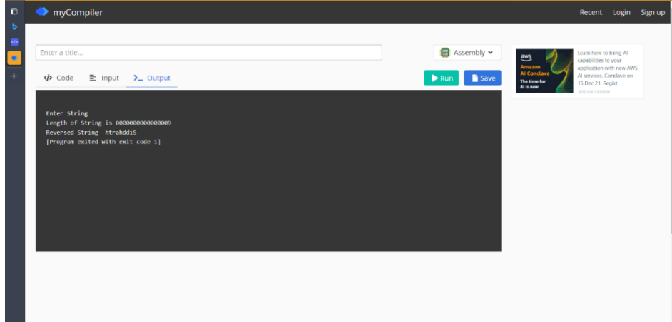

**Name**: Yashraj Vijay Aware

**Division**: D1

**Roll No**:224006

**Prn No**: 22110167